|  |  |
| --- | --- |
| **Canon EOS M50 Mark II (Black)**  Máy ảnh Canon EOS M50 Mark II (Black) + Kit 15-45mm f/3.5-6.3 IS STM  canon-eos-m50-mark-ii-2 canon-eos-m50-mark-ii-5 canon-eos-m50-mark-ii-10 canon-eos-m50-mark-ii-9 | **Featured information:**  * DIGIC 8 image processor * 24.1MP APS-C CMOS sensor * Dual Pixel CMOS AF with Eye Detect AF * Record UHD 4K and HD 720p120 video   Price : 1000$  **Specifications:**   * **Sensor Format:** APS-C (1.6x Crop Factor) * **Resolution:** 24.1 megapixels * **Size photo:** 6000 x 4000 * **Image Proportions:** 1:1, 3:2, 4:3, 16:9 * **Sensor Type:** CMOS * **Image Format:** JPEG, Raw * **Anti-Vibration:** Digital, 5-Axis (Video Only) * **Lens Mount:** Canon EF-M |

**Description:**

#### **APS-C 24.1MP CMOS sensor and DIGIC 8 image processor**

Both a 24.1MP APS-C CMOS sensor and DIGIC 8 image processor are used to deliver high-sensitivity, fast camera performance suitable for still and video shooting. The ISO range spans from 100-25600 with an expandable setting of ISO 51200 suitable for a variety of lighting conditions.

#### **Machine design and wireless connection set**

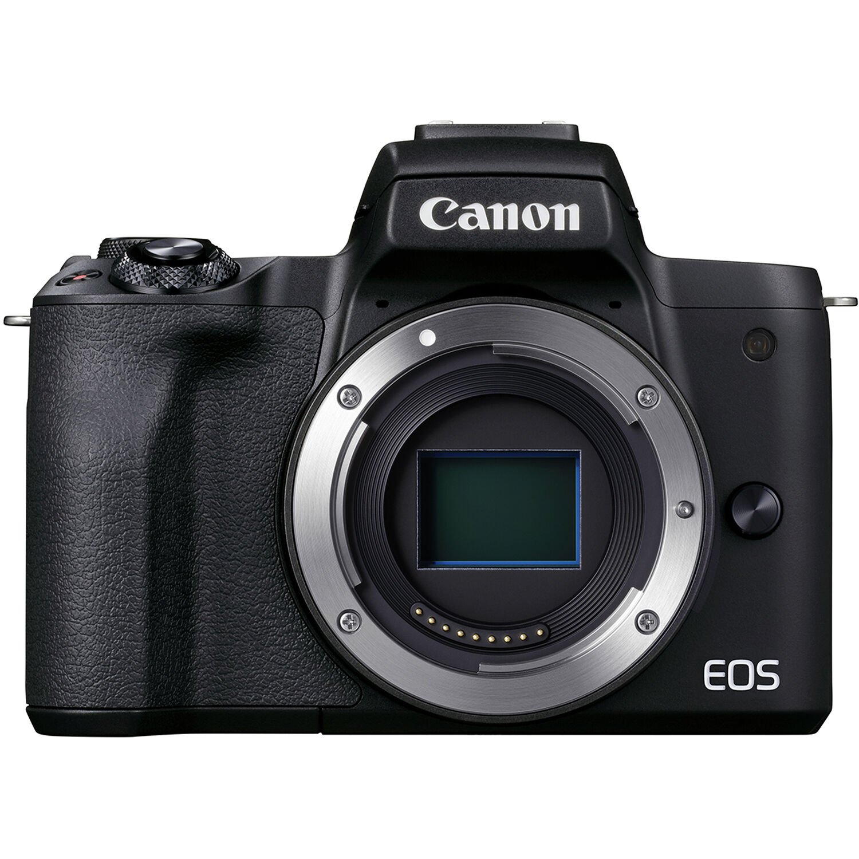

Dual Pixel CMOS AF on the Canon EOS M50 II provides fast and smooth focusing performance similar to how a camcorder focuses. This system integrates two individual photodiodes in each pixel to provide a wide and dense network that collects phase detection elements across the majority of the sensor. This reduces focus hunting for faster and more direct control of focus position

